**Intelligent transport system using VANET for emergency medical services**

**A project report**

***Submitted by***

|  |  |
| --- | --- |
| **Srivatsan Narasimhan** |  |

***in partial fulfilment for the award of the degree of***

**Bachelor of Technology in**

**Information Technology**



**Madras Institute of Technology, Chromepet**

**Anna university: Chennai 600 025**

**April 2018**

**ANNA UNIVERSITY::CHENNAI 600 044**

**TABLE AND CONTENTS**

|  |  |  |
| --- | --- | --- |
| **CHAPTER NO.** | **TITLE** | **PAGE NO.** |
|  | **BONAFIDE** | **ii** |
|  | **ACKNOWLEDGEMENTS** | **iii** |
|  | **ABSTRACT** | **iv** |
|  | **LIST OF FIGURES** | **v** |
|  | **LIST OF ABBREVIATIONS** | **vi** |
| **1** | **INTRODUCTION** |  |
|  | 1.1 Vehicular ad hoc network - an overview | 1 |
|  | 1.2 Vehicular ad hoc network - challenges | 5 |
|  | 1.3 Problem statement | 7 |
|  | 1.4 Objective | 8 |
|  | 1.5 Scope of the project | 9 |
|  | 1.6 Organization of report | 9 |
| **2** | **LITERATURE SURVEY** |  |
|  | 2.1 Time critical vehicle routing problem | 11 |
|  | 2.2 Traffic control system | 12 |
|  | 2.3 Advanced real time traffic monitoring system | 12 |
|  | 2.4 Enhancing Real-time Emergency healthcare services using VANET techniques | 13 |
|  | 2.5 VANET Services in Emergency situations | 14 |
|  | 2.6 Traffic flow control for megapolis cities | 14 |
|  | 2.7 Efficient vehicle to vehicle communication protocols for VANETs | 15 |
| **3** | **PROPOSED WORK** | 16 |
|  | 3.1 INTRODUCTION | 16 |
|  | 3.2 SYSTEM ARCHITECTURE | 16 |
|  | 3.3 SYSTEM DESIGN | 17 |
|  | 3.3.1 Mobility model | 17 |
|  | 3.3.2 VANET | 18 |
|  | 3.3.2.1. Vehicle to Vehicle communication | 18 |
|  | 3.3.2.2. Road Side Unit (RSU) | 18 |
|  | 3.3.2.3. Routing Protocol | 19 |
|  | 3.3.3. VEHICLE PATH SELECTION | 19 |
|  | 3.3.4. DYNAMIC ROUTING OF VEHICLES | 20 |
| **4** | **ALGORITHM AND IMPLEMENTATION** |  |
|  | 4.1 Intelligent Transport System Algorithm | 21 |
|  | 4.2 Simulation of Vehicles and Traffic | 26 |
|  | 4.3 Dissemination of Packets | 28 |
|  | 4.4 Priority to Emergency vehicles | 29 |
|  | 4.5 Rerouting of vehicles | 31 |
| **6** | **RESULTS AND DISCUSSION** |  |
| **7** | **CONCLUSION AND FUTURE WORK** |  |
|  | 7.1 Conclusion | 37 |
|  | 7.2 Future work | 37 |
| 7 | **APPENDIX 1** | 38 |
|  | **APPENDIX 2** | 42 |
| 8 | **REFERENCES** | 45 |

**ABSTRACT**

The Intelligent Transport System (ITS), provides innovative services related to different modes of transport, different kind of roads and traffic management, that various users to be well informed and make safer, more coordinated and smarter use of Transport systems. The current challenges in emergency medical services include taking more time for transportation to reach a patient, to transport the victim, to slow down by the traffic. The main objective is to provide a proper framework for Traffic monitoring system and to manage traffic by rerouting vehicles. In the existing approach the traffic constraint is not considered for the propagation of the emergency services. Congestion is usually looked at as the number of vehicles that pass through a point in a window of time, or a flow. In the proposed work, ITS framework is designed to monitor and control traffic using Vehicular ad-hoc networks (VANETs). Using ITS the cars in a network can communicate with each other and thus by dissemination of data between the vehicles, the efficiency of the transport system can be increased. So when an emergency vehicle arrives the nearby vehicles are notified for emergency and the priority is given to the emergency vehicle so that the other cars causing traffic are rerouted and made to change the lanes to provide way to the emergency vehicle. Using the ITS framework it is noted that the Traffic density is decreased by 25% (approximately) and the Transit time for vehicles has been reduced by 10%(approximately).

**LIST OF FIGURES**

|  |  |  |
| --- | --- | --- |
| **FIGURE NO.** | **TITLE** | **PAGE NO.** |
| 1.1 | Collision warning - VANET | 3 |
| 1.2 | Vehicular ad-hoc network | 4 |
| 1.3 | Vehicle to X communication | 7 |
| 3.1 | System architecture for Intelligent Transport System | 16 |
| 5.1 | Tapas Cologne (Germany) data set | 33 |
| 5.2 | Tapas Cologne data set - vehicle departure in each second | 33 |
| 5.3 | Time variant graph without traffic model | 33 |
| 5.4 | Time variant graph with traffic model | 34 |
| 5.5 | Vehicle traffic in a junction | 35 |

**CHAPTER 1**

**INTRODUCTION**

* 1. **VEHICULAR AD HOC NETWORKS - AN OVERVIEW**

**Vehicular ad hoc networks** (**VANETs**) are created by implementing the principles of mobile ad-hoc related network the spontaneous creation of a wireless connectionless network for data transfer to the domain of the vehicles. VANETs were first mentioned and introduced  in 2001 under "car-to-car ad hoc mobile communication and networking" applications, where networks can be formed and information can be relayed among cars. It was shown that vehicle-to-vehicle and vehicle-to-roadside communications architectures will co-exist in VANETs to provide road safety, navigation, and also has its applications in **Emergency Medical Services**. VANETs are a key part of the intelligent transportation systems (ITS) framework. Sometimes, VANETs are referred as Intelligent Transportation Networks. The term VANET became the mostly used synonymous word with the more generic used term of the **inter-vehicular communication** (**IVC**).

VANETs support a wide range of applications from simple one hop information dissemination of, e.g., cooperative awareness messages (CAMs) to multi-hop dissemination of messages over vast distances. Rather than moving at random, vehicles tend to move in an organized fashion. The interactions with roadside equipment can likewise be characterized fairly accurately. And finally, most vehicles are restricted in their range of motion, for example by being constrained to follow a paved highway. Vehicles are likely to move in structured way. The connection with wayside equipment can similarly be indicated absolutely accurately. In the end, mostly automobiles are limited in their motion range, such as being controlled to pursue a paved way. VANET suggests unlimited advantage to companies of any size. Vehicles access of fast speed internet which will change the automobiles on-board system from an effective widget to necessary productivity equipment, making nearly any internet technology accessible in the car. If a traveler downloads his email, he can transform jam traffic into a productive task and read on-board system and read it himself if traffic stuck. One can browse the internet when someone is waiting in car for a relative or friend. If GPS system is integrated it can give us a benefit about traffic related to reports to support the fastest way to work. Finally, it would permit for free, like Skype or Google Talk services within workers, reducing telecommunications charges.

The use of Vehicular Ad Hoc Networks (VANETs) technology to provide an Intelligent Transport System for the Emergency medical services can efficiently increase the life expectancy of the person and can provide the required medical services within time to the save the person’s life. The vehicles on roads are increasing, hence, controlling the traffic flow is highly challenging. One of the solutions for having efficient traffic flows and better mobility is to rely on intelligent traffic monitoring systems. These systems allow road operators to implement intelligent traffic management strategies such as the dynamic adjustment of timing, dynamic re-routing of vehicles in case of accidents or to make way for emergency vehicles by phasing of traffic lights and the adaptive road congestion charging. Moreover, better informed travellers will plan smartly their journeys and hence potentially contribute in reducing traffic jams.

Example applications of VANETs are:

**Electronic brake lights**, which allow a driver (or an autonomous car or truck) to react to vehicles braking even though they might be obscured (e.g., by other vehicles). Safety applications in vehicular networks have been popular research topics in recent years, such as forward collision warning (Figure 1.1), emergency braking warning and intersection collision warning systems. The basic safety message broadcast from each car transmits the position, car speed and car heading information. Neighbouring cars receiving this information can decide if there is any danger within the next second.

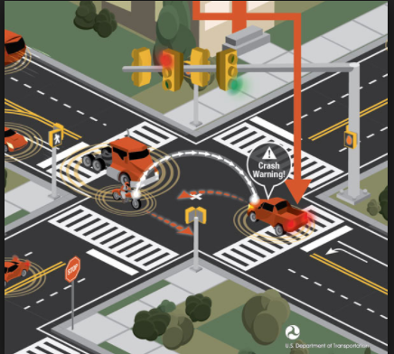

Figure 1.1: Collision warning - VANET

[**Platooning**](https://en.wikipedia.org/wiki/Platoon_(automobile)), which allows vehicles to closely (down to a few inches) follow a leading vehicle by wirelessly receiving acceleration and steering information, thus forming electronically coupled "road trains". This will help in efficient usage of road space thus reducing the traffic accumulation in roads and efficient transport without any accidents.

**Traffic information systems**, which use VANET communication to provide up-to-the minute obstacle reports to a vehicle's satellite navigation system. This could improve the efficiency of Intelligent transportation system because all the parameters are monitored so as to avoid any collision or accident.

**Road Transportation Emergency Services** - where VANET communications, VANET networks, and road safety warning and status information dissemination are used to reduce delays and speed up emergency rescue operations to save the lives of those injured. As in Figure 1.2, A VANET system may use the dissemination of messages between different vehicles and intimate the nearby vehicles that an emergency vehicle is approaching them and warn them to give way to the vehicle.

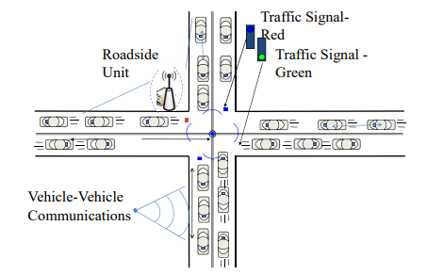

Figure 1.2: Vehicular ad-hoc network

**On-The-Road Services** - It is also envisioned that future transportation highway would be one that is "information-driven" and "wirelessly-enabled". When one drives on the road, VANETs can help the driver to discover services (shops, gas stations, etc) on that street, and even be notified of any sale going on at that moment. Drivers can also book a cinema ticket while driving their way to the cinemas. This could allow the user to have a complete view of his/her surroundings to know about the nearby areas.

* 1. **VEHICULAR AD HOC NETWORKS - CHALLENGES**

Although there has been an ample amount of research in VANET, still there are many areas which need to be looked into. Due to the different nature of VANET form many other wireless communication networks and hard design requirements, there are many interesting research problems in this field.

**Quality of Service (QoS):**

Provision of certain quality of service levels in VANET is an important task. A network with minimum delay for data delivery, less retransmissions, and high connectivity time can provide certain QoS guaranteed to the users. Promising this kind of QoS with different user applications and dynamic network environment is an interesting and challenging task in VANET design.

**Efficient Routing Algorithms Design:**

In order to timely and properly sending data packets from one node to another node an efficient routing algorithm is required. In VANET, efficient routing algorithm means a routing scheme with minimum delay, maximum system capacity and less computational complexity

**Scalability and Robustness:**

Designing a scalable and robust network remains an open area of research in VANET because of its challenging characteristics. Many design approaches fall short when VANETs transform from sparse to high dense mode, or from high mobility to slow traffic scenarios. A complete VANET framework that is scalable to different network scales and robust to the topological changes is required. This is an emerging area of research for VANET environment.

**Co-operative Communication:**

A key challenge in VANET is establishing the communication among different nodes. Different concepts of co-operative communication from wireless network theory may not be directly applied to VANET. This co-operative communication, such as up to which extent nodes should exchange information among themselves, is one of the key research areas in the VANET design.

**Network Security:**

As the nodes in VANET environment seek exchange of information among each other all the time, making sure that certain critical privacy information remains within the concerned node is an important design aspect. Designing a proper authentication mechanism and a trust based security protocol is an interesting and open research area in VANET.

**Real time implementation:**

For the proper working of the VANET, it must be made sure that each and every moving vehicle in the road or a path must contain a router IEEE 802.11 WiFi module such that it can connect to the Road Side Units(RSU) in each path and also with the other neighbouring cars (in Figure 1.3) so as to provide an Intelligent Transportation system for the Emergency Services.

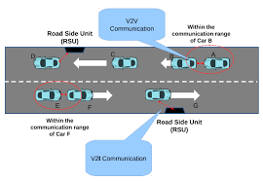

Figure: 1.3 Vehicle to X communication

**Traffic signal manipulation for multiple Ambulances:**

When two or more ambulances are encountered in opposite sides and when there comes a problem in manipulation of the Traffic signals for which ambulance is to be given first priority. So to overcome this problem each ambulance broadcasts another parameter, i.e the severity of the patient’s health. So based on this the RSU’s make the decision on which ambulance gets the first priority based on the patient’s health condition.

* 1. **PROBLEM STATEMENT**

The Intelligent Transport System provides innovative services related to different modes of transport, different kind of roads and traffic management, that various users to be well informed and make safer, more coordinated and smarter use of Transport systems. The current challenges in emergency medical services includes taking more time for transportation to reach a patient, to transport the victim, to slow down by the traffic. The main objective is to provide a proper framework for Traffic monitoring system and to manage traffic by re-routing vehicles. In the existing approach the traffic constraint is not considered for the propagation of the emergency services. Congestion is usually looked at as the number of vehicles that pass through a point in a window of time, or a flow. In the ITS design a module to monitor and control traffic using Vehicular ad-hoc networks (VANETs). Using VANET the cars in a network can communicate with each other and thus by dissemination of data between the vehicles, the efficiency of the transport system can be increased. So when an emergency vehicle arrives the nearby vehicles are notified and the priority is given to the emergency vehicle such that the other cars are rerouted or made to change lanes to give way to the former emergency vehicle. So the above mentioned Vehicle based ad-hoc network is used in Emergency medical services.

* 1. **OBJECTIVE**

Traffic is a major concern for most of the metropolitan cities of the world. The speed with which emergency personnel provide treatment is crucial to reduce criticality among patients. The main issue faced by the emergency services is the increasing amount of traffic in cities and other areas. The main objective is to provide a framework for Intelligent Transportation system using Vehicular Ad-Hoc networks(VANETs) and to manage traffic by manipulating traffic signals and re-routing vehicles to give priority route to Emergency medical services. As time is a crucial factor for emergency services, it is necessary to provide a proper solution for the existing traffic problem. Hence and a framework for Intelligent Transportation system using Vehicular Adhoc Networks(VANET).

The current challenges in emergency medical services includes taking more time for transportation to reach a patient, to transport the victim, to slow down by the traffic. In the existing approach the traffic constraint is not considered for the propagation of the emergency services. Congestion is usually looked at as the number of vehicles that pass through a point in a window of time, or a flow. With the help of Intelligent Traffic Control System (ITSC), which is based on a simple principle, being that a car can only move ahead if there is space for it and the signal remains green until the present cars have passed the traffic can be efficiently monitored and controlled. By implementing the Vehicular Ad-Hoc Networks, the traffic congestion can be controlled by making all the vehicles communicate with each other, so as to provide an Intelligent Transportation service. Using VANET the cars in a network can communicate with each other and thus by dissemination of data between the vehicles, the efficiency of the transport system can be increased. So when an emergency vehicle arrives the nearby vehicles are notified and the priority is given to the emergency vehicle such that the other cars are rerouted or made to change lanes to give way to the former emergency vehicle.

* 1. **SCOPE OF THE PROJECT**

The proposed Intelligent Transport system framework is being simulated in the Simulation of Urban Mobility (SUMO) software and also with Network Simulator 2. In future a real time simulation can be done when all the vehicles are manufactured with a Wi-Fi(802.11) router using which all the vehicles can communicate with each other and form a connected network. Thus simulation can be made real time with the help of vehicles with routers running in a geographical location to be made to connect with nearby vehicles and also Road Side Units kept at a finite distance at each path or road. Tapas Cologne traffic data set for an entire day is used.

**1.6 ORGANIZATION OF REPORT**   
 The Organization of report is organized as follows Chapter 1 gives a brief overview of the Vehicular ad hoc network. Chapter 2 analyses and getting various notions from various international conference papers and journal papers. Chapter 3 describes modules that are to be implemented, describes the system architecture and functional architecture that is to be implemented. Chapter 4 describes the execution details of each module and presents the screenshots of modules. Chapter 5 presents the evaluation and results of proposed systems. Chapter 6 contains the conclusion of the project and future enhancement that can be made on the existing works. Finally, it is followed by Reference Section where the details of various papers related to the project were listed.

**CHAPTER 2**

**LITERATURE SURVEY**

**2.1 TIME-CRITICAL VEHICLE ROUTING PROBLEM**

***Yixiao Huang et al (2017)*** [1] explicitly considers path selection in the road network as an integrated decision in the time-dependent vehicle routing problem, denoted as path flexibility (PF). Traditionally, vehicle routing problems are defined on a network in which the end-user locations are given. Typically, these arcs somehow represent the distances or expected travel time derived from the underlying road network. The quality of the solutions obtained from the vehicle routing problem depends on the quality of the road network representation. This means that any path between two customer nodes has multiple corresponding paths in the road network. Hence, the decisions to make are involving not only the routing decision but also the path selection decision depending upon the departure time at the customers and the congestion levels in the relevant road network. The actual routing problem depends upon the time factor with path flexibility. We formulate the TDVRP–PF models under deterministic and stochastic traffic conditions. We derive important insights, relationships, and solution structures. Based on a representative test bed of instances (inspired on the road network of Beijing), significant savings are obtained in terms of cost and fuel consumption, by explicitly considering path flexibility. Having both path flexibility and time- dependent travel time seems to be a good representation of a wide range of stochasticity and dynamics in the travel time, and path flexibility serves as a natural recourse under stochastic conditions. Exploiting this observation, we employ a Route-Path approximation method generating near-optimal solutions for the TDVRP–PF under stochastic traffic conditions.

**2.2 TRAFFIC CONTROL SYSTEMS**

***Raik Aissaoui et al (2014)*** [2] introduces a new digital-logic based system which is more efficient than currently used traffic control systems. Traffic is a major concern for most of the metropolitan cities of the world. Efficient traffic management can have a major impact on the country's economy. The Intelligent Traffic Control System (ITSC) is based on a simple principle; the principle being that "a car can only move ahead if there is space for it" and "the signal remains green until the present cars have passed". By placing sensors at every entry and exit of a junction and monitoring the number of cars present at the junction, it is

possible to make traffic very efficient, which is a good application of Digital Signal Processing. However, absolute advantage of such a system will only be felt if every junction in a city is controlled by this system.

**2.3 ADVANCED REAL-TIME TRAFFIC MONITORING SYSTEM**

[***Adwitiya Mukhopadhyay***](http://ieeexplore.ieee.org/search/searchresult.jsp?searchWithin=%22Authors%22:.QT.Adwitiya%20Mukhopadhyay.QT.&newsearch=true) ***et al*** (2016) [3] proposed a new real-time traffic monitoring based on emerging vehicular communication systems is proposed. The number of vehicles on roads keeps increasing continuously, making the management of traffic flow, especially in big cities more and more challenging. One of the key enablers for having smooth traffic flows and better mobility is to rely on real-time traffic monitoring systems. These systems allow road operators to implement intelligent traffic management strategies such as the dynamic adjustment of timing and phasing of traffic lights and the adaptive road congestion charging. Moreover , better informed travelers will plan smartly their journeys and hence potentially contribute in reducing traffic jams. Traditional real-time traffic monitoring usually get real-time data from GPS equipped fleets and fixed sensors installed in specific locations. The system enables traffic monitoring with higher reliability, accuracy, and granularity. The cluster-based V2X traffic data collection mechanism is able to gather more than 99% of the available data and reduce the overhead to one quarter when compared to other approaches.

**2.4 ENHANCING REAL TIME EMERGENCY HEALTHCARE**

**SERVICES USING VANET TECHNIQUES**

[***Peppino Fazio***](http://ieeexplore.ieee.org/search/searchresult.jsp?searchWithin=%22Authors%22:.QT.Peppino%20Fazio.QT.&newsearch=true) ***et al (2013)*** [4] focuses on creating a vehicular ad hoc network scenario for telemedicine, where an attempt is made to identify an optimal solution using 802.11 networking standard. Advancement in wireless technologies to improve telemedicine is one of the major goals in recent times. Wireless telemedicine for emergency primary healthcare is a technology which provides mobile healthcare and exchange of medical data from ambulances or rural healthcare centers to hospitals. This helps the hospitals to understand patients' medical condition before they arrive. The idea is to be prepared in advance for hospitals to respond to such cases. A vehicle-to-vehicle connection is created which has been evaluated using various node densities by choosing 802.11n, 802.11p and 802.11b with AODV (Ad-Hoc On demand Distance Vector) routing protocol. Constant bit-rate traffic is used between the ambulance and hospital. Validations for the standards are carried out for the parameters PLR (Packet Loss Ratio), delay and throughput considering blood pressure, video and audio transmission. The performance results are analyzed for all three standards based on mobility and varying vehicular speeds. We have compared the results of various parameters for each scenario and attempted to identify the better performing standard. NS3 has been used for simulation in networks, whereas for traffic simulation SUMO (Simulation of Urban Mobility) is used. [Peppino Fazio](http://ieeexplore.ieee.org/search/searchresult.jsp?searchWithin=%22Authors%22:.QT.Peppino%20Fazio.QT.&newsearch=true) et al (2013) uses a AODV - Ad-Hoc on demand Distance Vector as its routing protocol.

**2.5 VANET SERVICES IN EMERGENCY SITUATIONS**

***Rui Wang et al (2014)*** [5]proposed the application uses with peculiarities of the VANETs to advise danger or emergency situations with V2V and V2I message exchange. Car-to-car communication (C2C) makes possible offering many services for vehicular environment, mainly to improve the safety. The decentralized kind of these networks requires new protocols to distribute information. The V2X communication requires On-Board Units (OBUs) in the vehicles, and Road-Side Units (RSUs) on the roads. IEEE 802.11p is the standard on which the communication is based, that provides the PHY and MAC layers. The performance of the application will be evaluated through many simulations executed in different scenarios, to provide general data independent from them.

**2.6 TRAFFIC FLOW CONTROL FOR MEGAPOLIS CITIES**

***A.I. Diveeva et al (2016)*** [6] considers a problem of traffic flows control in congestion conditions. Controlling the traffic is performed on intersections using optimal traffic lights durations. The traffic phases durations are searched using already given

proposed traffic flows model which is based on the controlled networks theory. A large scale road network presents a prototype model which contains the connection matrices that describe the communications and interactions between input and output roads into smaller networks.

**2.7 EFFICIENT VEHICLE TO VEHICLE COMMUNICATION**

**PROTOCOLS FOR VANET**

In this paper proposed by ***Abdul Hafidz Abdul Hanana et al (2017)*** [7] vehicle to vehicle communication protocol is presented. Increase in comfort, safety and efficiency has made VANET a critical area of research. Inter Vehicular Communication (IVC) enhances the previously specified factors in VANET. Complex networking protocols and high cost infrastructure are the limitations of the VANETs. Success rate in transmission of messages has increased and the ratio of packet loss is less. Wireless communication is not trustable and complex and hence the efficient vehicle to vehicle communication is beneficial. Some factors that prevent messages from being successfully delivered in time are packet communication obstacles, collisions, and channel fading. Ad-hoc network formed by high density and mobility of vehicles are different from the VANET formed by nearby vehicles. A protocol for avoidance of vehicular collision communication has been proposed in this paper. Major contributions are:

* Requirements for Vehicle to Vehicle (V2V) collision avoidance mechanism in VANET.
* Congestion control in VANET at emergency situations.

The summary shows the challenges involved in providing the way for emergency services such as the velocity of the vehicles, density of the traffic, path selection and real time data analysis of the vehicle’s mobility should also be considered for providing an efficient ITS framework, which is provided by the proposed system.

**CHAPTER 3**

**PROPOSED WORK**

**3.1 INTRODUCTION**

In the proposed system(In figure 3.1) we design an module to monitor and control traffic using Vehicle ad-hoc networks (VANETs) . Using VANET the cars in a network can communicate with each other and thus by dissemination of data between the vehicles, the efficiency of the transport system can be increased. So when an emergency vehicle arrives the nearby vehicles are notified and the priority is given to the emergency vehicle such that the other cars are rerouted or made to change lanes to give way to the former.

**3.2 SYSTEM ARCHITECTURE**

The dynamics of physical parameters of highly unstable vehicular traffic environments is one of the key factors to be considered in the analysis of geocast routing protocols. In recently suggested geocast routing protocols, researchers have given importance to physical parameters of traffic environment while designing geocast routing protocols. The physical parameters considered for empirical analysis are VDT, traffic volume, IVD, speed, lane occupancy, and traffic variability. Traffic volume has a significant impact on the performance of geocast routing protocols. A high traffic volume on a road network results in information overload whereas a low traffic volume causes network disconnection. Traffic volume follows rapid changes in urban and rural traffic environments as compared to the highway traffic environment. The time-period of the day also plays a crucial role in traffic accumulation.

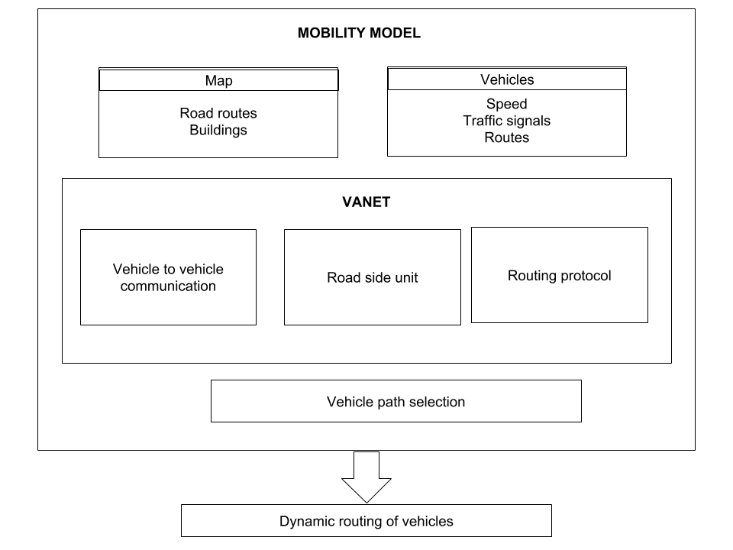

Figure 3.1: System architecture for Intelligent Transport System

**3.3 SYSTEM DESIGN**

The proposed design consists of mobility model, VANET, vehicle path selection , dynamic re-routing of vehicles.

**3.3.1 Mobility model**

The routes for simulation are taken from openstreetmap.org. It provides a free editable map of the world. The data transmitted between vehicles includes parameters such as speed, direction of the vehicle, destination, routes etc.The mobility model consists of map in which the roads, traffic lights, road side units, buildings, vehicles are simulated. The vehicle part contains the type, speed, routes in simulation integrated with the map.

**3.3.2 VANET**

**VANETs** (Vehicular ad hoc networks) are based on the working of MANETs (Mobile ad hoc networks). MANETs are the spontaneous creation of a wireless network for data exchange – to the domain of vehicles. Vehicle-to-vehicle and vehicle-to-roadside communications architectures will co-exist in VANETs to provide road safety, navigation, and other roadside services. WiFi IEEE 802.1p (WAVE standard) and WiMAX IEEE 802.6 are used in **Intelligent Vehicle Ad-hoc Network** for easy effective communication between vehicles. Road Side Units (RSU) are access points which enable vehicles to communicate among themselves (Vehicle-to-vehicle, V2V) and they are also known as roadside access points. Lifetime Routing Protocol is used in VANET.

**3.3.2.1. Vehicle to Vehicle communication:**

Vehicle to Vehicle communications are networks where the vehicles communicate within each other and certain vehicles communicate with the road side unit providing information regarding the traffic in the road, vehicle types, speed of the vehicle, destination etc.. This information is useful in avoiding congestion between vehicles and accidents. These kind of nodes are called dedicated short-range communications(DSRC) devices. DSRC works in 5.9 GHz band with bandwidth of 75 MHz and approximate range of 300 m. Vehicular communications is usually developed as a part of intelligent transportation systems(ITS).

**3.3.2.2. Road Side Unit (RSU):**

Vehicles are connected to the Road Side Units (RSU) through VANET. RSUs are connected to the internet allowing them to communicate with each other and with the vehicles. RSUs and vehicles share various types of information. RSU are used as data disseminators, security managers, service proxies, location servers and traffic directories.

**3.3.2.3. Routing Protocol:**

Different types of routing protocols are proposed. Topology based routing protocols are classified as proactive and reactive routing protocols. These routing protocols start transmission before the discovery of route from start to the destination. In proactive routing protocols route discovery is initiated to all nodes in the entire network which results in increase in end-to-end delays and control overhead. While in reactive routing protocol the control overhead is reduced since the discovery to the desired location is only initiated. But for every first time of communication with the new node, the route discovery process is required.

Ad hoc network is composed of a group of nodes with routing function. It is a kind of distributed wireless multihop network. The nodes in Ad hoc network have low transmission range. An auxiliary node is usually required when the source node sends data to the target node. So the routing protocol is necessary in ad hoc network.

**3.3.3. VEHICLE PATH SELECTION**

In order to improve the VANETs, performance and throughput the routes among nodes should have reliability, stability and comparatively less overhead. Hop count is used as a metric in most of the existing routing protocols to distinguish between the routes. Estimation of reliable path in VANET is a difficult task because the routing depends on many factors like the number of jumps, the direction, the range of the transmission, the speed of the nodes and the density of the nodes.

**3.3.4. DYNAMIC ROUTING OF VEHICLES**

Traffic jams leads to rapid changes in topology. It disturbs the homogeneous distribution of vehicles on road. Dynamic transmission range reduces the effects of high transmission power while effectively maintaining connectivity. The density estimate can be calculated and into free-flow or congested traffic. An algorithm is developed using the density estimate that dynamically changes the vehicle transmission range according to local transmission conditions. Based on the information available, the vehicles are rerouted using ITS algorithm and the path to be taken is informed to the vehicles once the vehicle to vehicle communication is established.

**CHAPTER 4**

**ALGORITHM AND IMPLEMENTATION**

**4.1 INTELLIGENT TRANSPORT SYSTEM ALGORITHM**

**Input :** Vehicle routes

**Output :** Optimal route and prioritization for ambulance

1. Begin
2. for each vehicles
   1. Set vehicle[i] ← unique vehicle id

end for

1. for every Traffic signal & Detectors ← Unique ID
2. for each vehicles
   1. assign a Road Side Unit for each vehicle

end for

1. for each vehicle
   1. update local table of RSU for vehicles

end for

1. for each vehicle in the cluster
   1. vehicle Transmits packet to other vehicle

end for

1. While categorizing data
   1. vehicle in cluster ← number of vehicles in network / number of clusters
   2. Update local table[vehicle[i]] periodically

end while

1. If Vehicle ID == "Emergency vehicle"
   1. If alternative shortest route to destination→true
      1. Change route ← [Vehicle[i]]
   2. Else
      1. Change l.ane[vehicle[i]

End if

* 1. Set route[Vehicle ID à Emergency Vehicle

End if

1. While detectors receive packets
2. If Vehicle ID == "Emergency vehicle"
   1. traffic signals[j] == (Green)

End if

1. if vehicle[Vehicle ID == emergency vehicles]
   1. Vehicle[Vid] set ‘highest priority’.

End if

End while.

End

In the modified ITS algorithm, each vehicles are given an unique vehicle Id. The traffic signal and traffic detectors are also given the unique Id in order to distinguish vehicles from traffic lights and detectors. Then each vehicles are detected by the corresponding road side units(RSUs). The Local table of the RSUs are updated periodically in order to know which vehicles are connecting to that RSU. Each vehicles transmits packets with their unique id, speed, destination, source, type of vehicle etc. embedded to the message to be sent to other vehicles. And each vehicle on receiving the packets update their respective table periodically, this will be done while separating the data from the messages passed within the vehicles.

If the type of the vehicle is emergency vehicle then the alternative shortest route for the corresponding emergency vehicle is found and the routes to be taken by the other vehicles in order to avoid traffic and make way for the emergency vehicles is done. But if there is no possibility for taking alternate routes then at least changing the lanes of the vehicles in order to clear the traffic as much as possible.Then the route for emergency vehicle is set. While the detectors receive the packet by checking the vehicle type, if it is emergency vehicle then change the traffic signals to green and other corresponding junction traffic signal to red. And also set the emergency vehicle to have the highest priority in giving the path for the vehicle than the other vehicles.

Life Time (LT) of all vehicles are calculated at any given time within the associated clusters. The time each vehicle will remain in the cluster determines LT. This time depends on factors such as the distance to upcoming directional threshold point of the cluster and the velocity. The vehicle with the maximum lifetime will be selected as Cluster Head (CH). It remains as the CH till it reaches directional threshold point. After the point a new CH is selected from the election. Not updating the CH all the time will minimize the control overhead messages which is the result of re-election algorithm.

**Algorithm for Life Time Routing protocol:**

1. for t = anytime and t <= simulation time do
   1. if Packet received by CH at time = t
      1. Check Routing table of the CH
      2. if Routing table NOT empty then
         1. Store the closest Chs to destination in CandiCHtable
         2. if CandiCHtable has two or more CH with same maximum LT

NextCH = CH that closest to the destination

* + - 1. else

NextCH = CH with maximum LT

end if

* + 1. else
       1. Store and Forward

end if  
 end if

end for

**Lifetime(LT) Calculation:**

LT (i): Life-Time of vehicle i

dith: Distance between vehicle i and directional edge of the cluster

Vi : Velocity of vehicle i

**Distance Calculation:**

Dth (CID): Threshold Distance for specific cluster

VCH (CID): CH Velocity for specific cluster

HOT : Hand-Over Time

CID: Cluster Identification

The packets are propagated within the segment through the selected CH in Life Time Routing (LTR) protocol. Routing tables are built in each CH and stores in it the adjacent CH IDs, LT, and expiry time, associated locations. Expiry time keeps the contents of the routing table updated. When the local CH receives a packet, it looks up its routing table for the candidate CHs that are located toward the destination location irrespective of moving direction, and packets are forwarded to the next CH that has the maximum LT. The CH in the same direction of the local CH is selected if two candidate CHs with equal LT are available for forwarding the packets. As recovery process the local store-and-forward process is followed in CH if there are no relaying CH to the destination. The packets are stored in specific buffer and keeps moving till another relaying CH is found.

**MATHEMATICAL MODEL FOR VEHICLE SHORTEST ROUTE:**

*Time(Source-Destination)i = Distancei / Velocityi*

*Time(Breadth)i = Breadth_road + (Breadth_vehiclesi) / Velocityi*

*Traffic_inpathi = (Route_Distancei / Avg. speed) - (Route_Distancei / Top speed)*

*Traffic_inpath_avg. = Traffic_inpathi / n*

*Route_traffic_timecalci= Time ( Source - Destination )i + Time ( Breadth )i + Traffic_inpath_avg.i*

*Shortest_routetime = min( Route_traffic_timecalc1, Route_traffic_timecalc2…. )*

The mathematical model mentioned will be useful in determining the path of the vehicle based on the estimation of the traffic in the route to be taken. By the general formula for time we are calculating it for all the vehicles in the network. The traffic of the whole path is estimated by means of dividing the distance of the route by top speed of the vehicle in that particular network subtracting this from the time obtained over division of distance by average speed of all vehicles in the network.

Then average of all the paths are found by dividing the traffic in path by the number of vehicles. The overall traffic of the route is calculated by adding breadth of the road with time to reach the destination and the traffic average for the whole path. Then in order to suggest the minimal traffic route to the emergency vehicle we wanna find the minimum of all the route traffic.

**4.2 SIMULATION OF VEHICLES AND TRAFFIC**

SUMO is the Simulation of Urban mobility software that enables to simulate the road traffic. The Simulation of Urban Mobility software is used to simulate the real time traffic in an environment or an road area in a Geographical location. The SUMO is capable of simulating larger networks such as a real time traffic monitoring including simulation of different vehicle types with multilane capabilities and can also simulate emergency type vehicles. The traffic signals can also be simulated using the SUMO and such that the vehicles can be rerouted by manipulating the Traffic signals. The Netconvert option in the SUMO software is used to convert the different network files and road networks from any other formats into SUMO format. Using the Netedit option we can edit the network files in the simulator. The Net-generate option generates abstract network for SUMO simulation. The polyconvert option imports points of interest and polygons from different formats and translates them into a description that may be visualized by SUMO-GUI. The Open Street map provides the xml based .osm file for any part of the world selected through their website.

$] netconvert --osm-files map.osm -o map.net.xml

This converts the OSM map file into an XML file.

$] polyconvert --osm-files map.osm --net-file map.net.xml --type-file osmPolyconvert.typ.xml -o map.poly.xml

Copy the polyconvert file from SUMO home to the required folder. The polyconvert file has the details of the terrains in the map including the buildings, flyovers, railway lines etc.

$] python $SUMO_HOME/tools/randomTrips.py -n map.net.xml -r map.rou.xml -e 100 –l

This assigns cars randomly to the map, the randomTrips.py file generates cars randomly in the simulation map.

In the map.sumo.cfg file the remainder files such as the poly file, net file, the route files are given as inputs.

<net-file value="guindy.net.xml"/>

<route-files value="guindy.rou.xml"/>

<additional-files value="guindy.poly.xml"/>

In the network file the network components of the road network are stored and they can be included into the sumo simulator by including the net.xml configuration file. In the rou.xml file, the route paths for all the available routes in that network or geographical area is present. By including this configuration file the basic routes available for a network is embedded into the sumo simulator upon which the routes can be allocated for the vehicles that will be used in the simulation. The poly.xml file is used to denote the buildings, structures and rivers bridges present in the real map file and these structures are included in the simulator by using this configuration file.

The beginning and ending time for the simulator is also given as input in this CFG file. Using this input the SUMO invokes the starting of the simulation and ends it once the end time is reached. For an instance the beginning time is given as 0 and the simulation runs upto 100 which is the end time.

Run the SUMO software by sumo-gui map.sumo.cfg

**4.3 DISSEMINATION OF PACKETS**

Exporting from SUMO to NS2.

*$] sumo -c guindy.sumo.cfg --fcd-output guindy.sumo.xml*

The sumo.cfg file is converted into an XML file using the options given by SUMO and the converted xml file can then be configured and given as input for the network simulator.

*$] python /home/srivatsan/sumo-0.26.0/tools/traceExporter.py --fcd-input map.sumo.xml --ns2config-output map.tcl --ns2activity-output activity.tcl --ns2mobility-output mobility.tcl​*

This will generate three tcl files (map.tcl, activity.tcl and mobility.tcl).

The map TCL file is the network file where the routing protocol is defined for transfer of the packets from one node to another and this file contains modules for the basic connectivity between all the nodes in a network. The activity and the mobility.tcl file has the mobility values of all the vehicles that are simulated as nodes in the network.

The network simulator is started by giving the command

*ns map.tcl*

The network animator is initiated by giving the command,

*nam map.nam.*

Once the network animator is initiated, with a delay the simulation can be started and then the nodes in the network can be visualised and each node’s connectivity and message passing between all other nodes can be seen in the network animator.

Now the map.tr file has all the packet traces information, it has all the packet exchange information between all other nodes which can be further analyzed. So using the Trace file all the vehicle’s movements can be traced and all the packet transitions are also logged into the Trace file.

**4.4 PRIORITY TO EMERGENCY VEHICLES**

The following python code has been implemented to detect a vehicle and give priority to the vehicle by changing the traffic signal. There are three routes North to South and East to West and West to East.

traci.init(PORT)

This command is used to initiate the python TraCI component and connect it with the SUMO simulator. Once it is connected with a server - client connectivity then the step value is given as 0 such that the vehicle’s movements can be measured with respect to its step value.

step = 0

For each direction in that junction having a traffic signal , a default initial signal has to be assigned such that there will be an initial traffic signal showing at the traffic signal when the simulation of the vehicles start. In the beginning, for the simulation purpose we assume that for phase 2 that is for the East- west road we assign green signal so that vehicles passing through that road can pass through the junction without any obstacles or no traffic due to vehicles waiting for signal. The below command sets that signals as green.

traci.trafficlights.setPhase("0", 2)

Now the vehicles path from the North to south is regularly monitored (The simulation of this loop starts only when there is at least any one vehicle entering that particular area) such that if any emergency vehicles are coming in that part. It has a detector which is placed at a definite position from the traffic signal, so when all the vehicles are monitored on the pathway for all other roads in a network or a geographical network. So whenever emergency vehicle is detected by using the vehicle ID value in the packet disseminated by all vehicles to the RSU(road side unit), the traffic signal is automatically manipulated to give green signal for the path or the road through which the ambulance is heading and thus the priority is given for that emergency situation.

If the detected emergency vehicle leaves that path or road then after some delay the traffic signal is changed after some delay such that the remaining vehicles in the other paths are cleared after the passing of the emergency vehicle.

There may arise some situations where the emergency vehicle may come on two or three road paths. In such cases the priority function can only be given to emergency vehicle arriving first. But in certain cases the emergency vehicle coming later may have some patients with critical conditions than the person in the former ambulance. So avoid this problem each ambulance along with the packets dissemination of arriving vehicles, each emergency vehicle updates the Road side units about the criticality of the person its carrying, such that when multiple ambulances come across a same junction, then the ambulance with higher criticality patient is let out first in the traffic area and priority is given based on this and traffic lights are manipulated in this way.

**4.5 RE-ROUTING OF VEHICLES**

Even though the traffic signals reduce the traffic density in the area, still at certain cases it may not be enough for emergency vehicles to pass through the traffic affected regions. So in that case the remaining vehicles around the emergency vehicles are rerouted to other areas, that is they are made to take any other alternative route to their destination without pursuing their current route in which the emergency vehicle has to travel. By doing this the vehicle density in an area is further reduced such that the emergency vehicle can pass through the road or path much faster than any normal situation without any of these precautionary methods. The proposed mathematical model in turn also calculates the amount of vehicles present in each and every node or path in an geographical area, so it also gives re-routing directions to the emergency vehicles such that the lane with limited or lesser number of vehicles/traffic can be selected as route for the emergency vehicle from its source to its destination.

**CHAPTER 5**

**RESULTS AND DISCUSSION**

The simulation of vehicles in a real world map is done by using the Simulation of Urban mobility software (SUMO) by embedding a real world map from the open street maps and the communication between the vehicles in the network has been achieved by using Network Simulator 2 (NS2). The number of vehicles in the network can be given as input and they are given random routes in the real world map.

Each vehicle in the network and in the simulator is observed and a graph is generated which gives the difference observed when the vehicles are run in a normal scenario without any Intelligent Transport system and with the Intelligent transport module embedded. It is noted that when the vehicles are using the ITS structure there is a reduce in traffic density and Transit time for the vehicle in the road network.

The mobility model has been observed for the Tapas cologne.The "TAPAS Cologne" simulation scenario describes the traffic within the city of Cologne (Germany) for a whole day. The original demand data stems from TAPAS (In Figure 5.1), a system which computes mobility wishes for an area population generated based on information about travelling habits of Germans and on information about the infrastructure of the area they live in. Based on the dataset we can observe the real time movements of vehicles in the city of cologne in a mapped time between 6:00 to 8:00 AM. Using this data the traffic movements in the area can be monitored and predicted such that the vehicle composition in certain area can be known and those heavily traffic affected areas can be avoided during its peak time. The figure 5.2 shows the vehicle departure per second in the simulation.

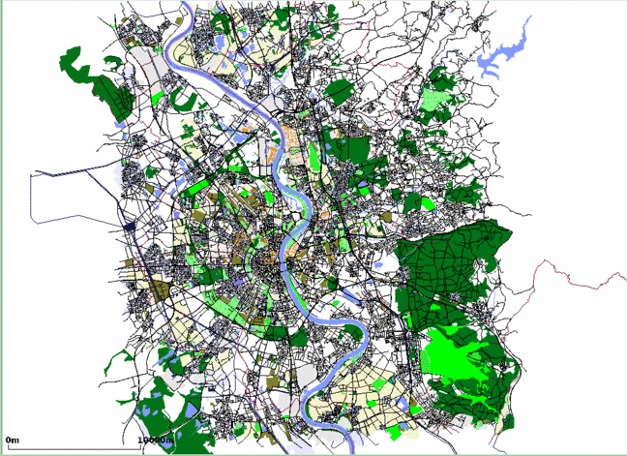

Figure 5.1: Tapas Cologne (Germany) data set

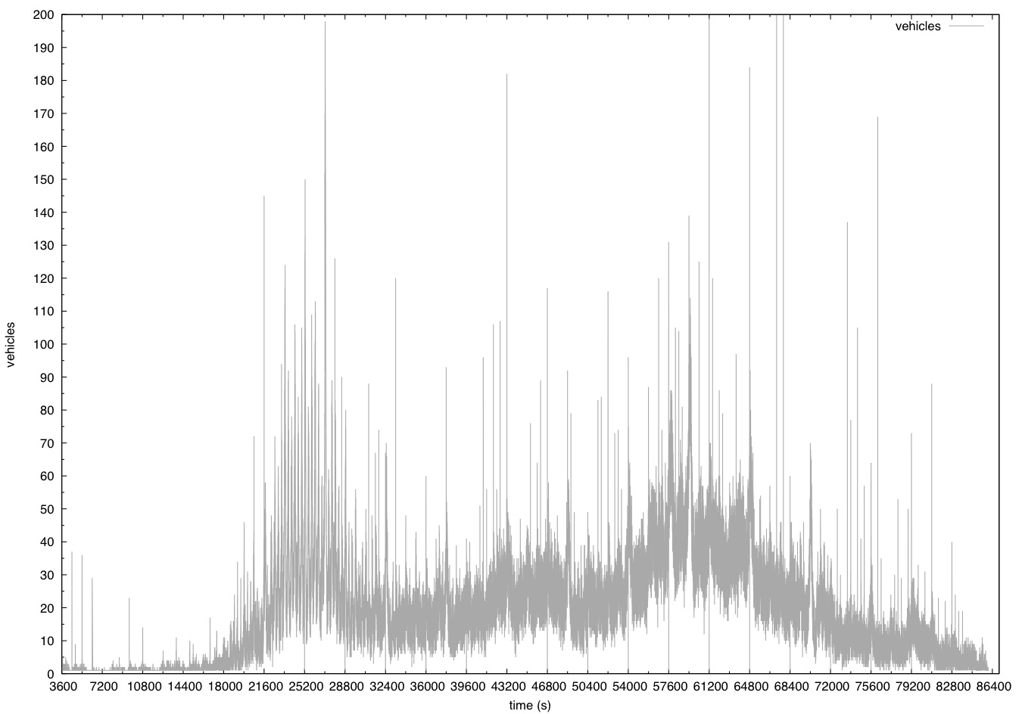

Figure 5.2 : vehicle departure in each second

In the figure 5.2, the graph is observed and it shows the vehicle departure at each time interval of the simulation time such that we can know that the vehicle count or density at the specified time in the simulation.

The Figure 5.3 shows the Time variant for the starting time, time at junction and the time at ending destination of the vehicle in the simulation without any traffic model ( ITS Model).

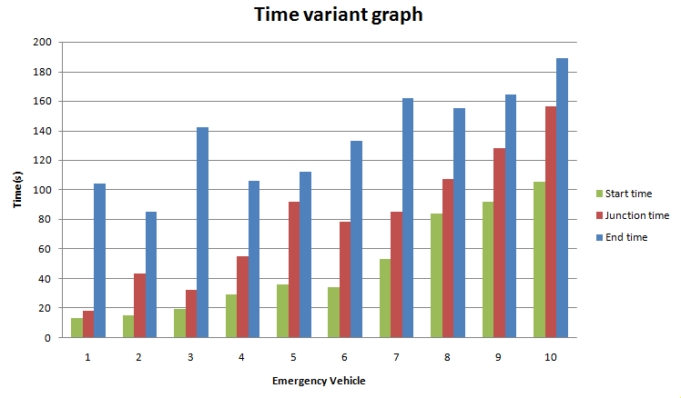

Figure 5.3: Time variant graph without traffic model

The Figure 5.4 shows the Time variant for the starting time, time at junction and the time at ending destination of the vehicle in the simulation with the proposed traffic model ( Intelligent Traffic System).

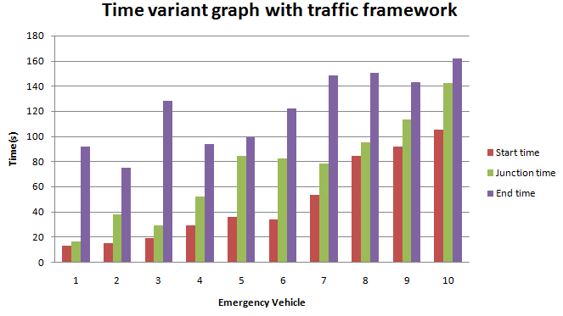

Figure 5.4: Time variant graph with traffic model

It is noted that when the vehicles are passing through a road network with the Intelligent Traffic system module incorporated, there is a decline in the transit time of the vehicles by a margin of around 10 percentage.

In figure 5.5, we can see a graph with two curves which denote the traffic density of vehicles in an area, or a junction in the simulation. It is noted that the upper curve is the traffic density of vehicles without the Intelligent Traffic system module and the lower curve with the lesser traffic density if of vehicles that monitored in a road or a junction with the Intelligent Traffic system module. It can be noted that there is a 25%(approximate) decrease in traffic density in the road network that has the Intelligent Transport system framework.

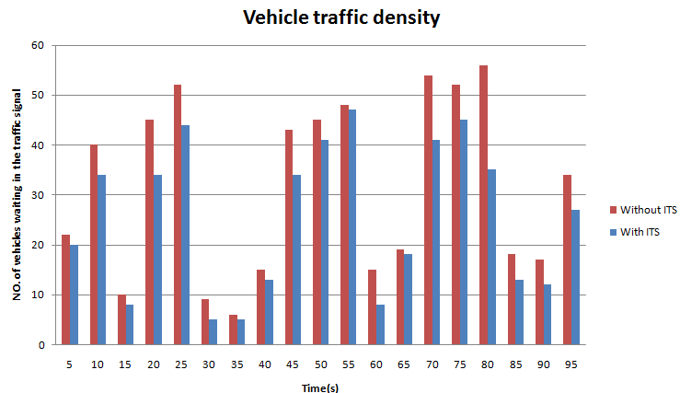

Figure 5.5: Vehicle traffic density in a junction

**CHAPTER 6**

**CONCLUSION AND FUTURE WORK**

**6.1 CONCLUSION**

In the Proposed work, Vehicular Ad-Hoc networks are incorporated in road networks to provide an Intelligent Transport system for Emergency vehicles, in which the basic communication between vehicles which are considered as nodes in a network has been done. The packets are transferred between all the vehicles in the network using the Network Simulator.

The detection of emergency vehicles in a street has been achieved using the TraCI (Traffic Controller Interface of Simulation of Urban Mobility). That is when an emergency vehicle is detected with the help of Road side units(Detectors), the traffic signals are automatically changed and priority is given to the emergency vehicle based on the criticality of the patient in the emergency vehicle.

re-routing of the vehicles is preemptively done when an emergency vehicle is detected. When there is more traffic in an area which cannot be just controlled by manipulation of traffic signals by changing lights, then the re-routing of the vehicles take place by re-routing the nearby vehicles around the ambulance to alternative routes to their destination.

**6.2 FUTURE WORK**

The efficiency of the dynamic re-routing algorithm can be improved. The transmit time of the emergency vehicle can be reduced further. In future the work is to extend various methods for different applications. The simulated work can be extended in real time also.

**APPENDIX 1**

**SIMULATION ENVIRONMENT**

**SUMO**

"Simulation of Urban MObility" (SUMO) is an open source, highly portable, microscopic and continuous road traffic simulation package designed to handle large road networks. SUMO is licensed under the Eclipse Public License V2.  
Normally, NETCONVERT and NETGENERATE generate traffic lights and programs for junctions during the computation of the networks. Still, these computed programs quite often differ from those found in reality. To feed the simulation with real traffic light programs, it is possible to run SUMO/SUMO-GUI with additional program definitions. Also, SUMO/SUMO-GUI allow loading definitions which describe when and how a set of traffic lights can switch from one program to another. Both will be discussed in the following subchapters. Another possibility is to edit traffic light plans visually in NETEDIT.  
  
**Rerouter**  
Rerouter changes the route of a vehicle as soon as the vehicle moves onto a specified edge.  
Rerouter may be placed on several edges, at least one edge is necessary. Furthermore, it is possible to define the probability for re-routing a vehicle by giving a number between 0 (none) and 1 (all) already within the definition.

**Calibrators**  
These trigger-type objects may be specified within an additional-file and allow the dynamic adaption of traffic flows and speeds. They can be used to modify simulation scenario based on induction loop measurements. A calibrator will remove vehicles in excess of the specified flow and it will insert new vehicles if the normal traffic demand of the simulation does not meet the specified number of vehsPerHour. Furthermore, the speed on the edge will be adjusted to the specified speed similar to the workings of a variable speed sign. Calibrators will also remove vehicles if the traffic on their lane is jammed beyond what would be expected given the specified flow and speed. This ensures that invalid jams do not grow upstream past a calibrator.  
  
**Features that cause re-routing**  
There are multiple simulation features that allow routing at simulation time. This type of routing works by assigning a re-routing device to some or all vehicles. Details are given at Demand/Automatic_Routing.This is a special case of the above method. Vehicles with incomplete routes automatically receive a re-routing device and are rerouted once when entering the network. In some scenarios this is a practical one-shot-approach to route assignment that avoids time-consuming iterative assignment.This is a location based method for triggering re-routing and is described at Simulation/Rerouter.By using <rerouter>-definitions, vehicles can be routed to alternative destinations. A different method is to use traffic assignment zones (TAZ). This allows vehicles to change their destination to the best alternative from a list of potential destinations.By default, the route with the least travel time is chosen. The following order of steps is taken to retrieve the travel time for each edge (If one step fails due to lack of data, the next step is taken):The vehicle retrieves it's individual data storage. This can be set and retrieved using the TraCI vehicle methods change edge travel time information and edge travel time information.The global edge weights loaded using option --weight-files are retrieved.The global edge weights (set and retrieved via TraCI) using the TraCI edge methods change edge travel time information and edge travel time information.The minimum travel time ( length / allowed Speed ) is used.

**TraCI**

TraCI is the short term for "Traffic Control Interface". Giving access to a running road traffic simulation, it allows to retrieve values of simulated objects and to manipulate their behaviour "on-line".Using the methods change target or reroute re-routing is triggered for the specified vehicle.

**NS2**

Ns is a discrete event simulator targeted at networking research. Ns provides substantial support for simulation of TCP, routing, and multicast protocols over wired and wireless (local and satellite) networks.  
Ns began as a variant of the REAL network simulator in 1989 and has evolved substantially over the past few years. In 1995 ns development was supported by DARPA through the VINT project at LBL, Xerox PARC, UCB, and USC/ISI. Currently ns development is support through DARPA with SAMAN and through NSF with CONSER, both in collaboration with other researchers including ACIRI.

**APPENDIX 2**

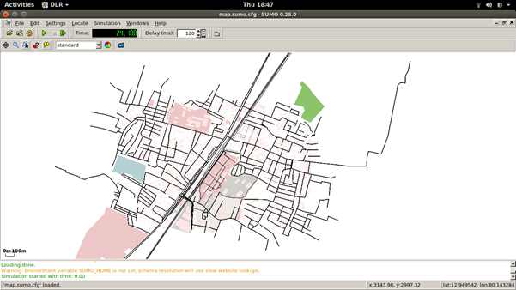

Figure A1:SUMO Dataset

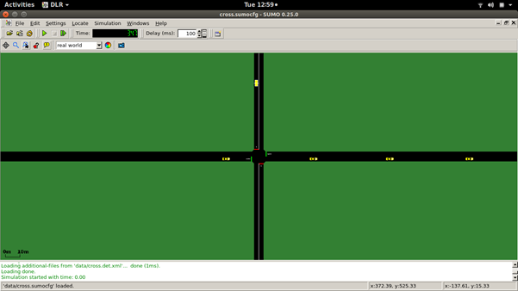 Figure A2:Simulation of the Traffic signals

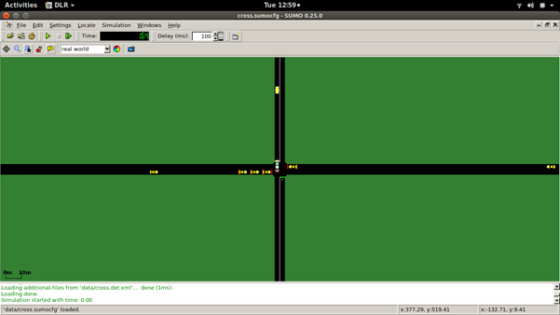

Figure A3:Priority for Emergency vehicles

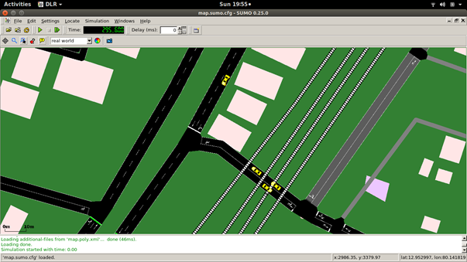

Figure A4:Simulation of real time map

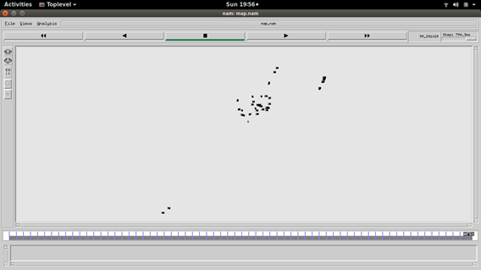

Figure A5:Packet communication in ns2

**REFERENCES**

[1] Yixiao Huang, Lei Zhao, Tom Van Woensel, Jean-Philippe Gross, “Time-dependent vehicle routing problem with path flexibility“, Elsevier journal, Transportation journal part B 95 (2017), Vol. 95,No 3, pp. 169-195.

[2] Raik Aissaoui, Hamid Menouar, Amine Dhraief, Fethi Filali, Abdelfettah Belghith, Adnan AbuDayya, “Advanced Real-Time Traffic Monitoring System based on V2X communications , IEEE ICC 2014 - Mobile and Wireless Networking Symposium, Vol. 32,No 5, pp. 15-43.

[3] [Adwitiya Mukhopadhyay](http://ieeexplore.ieee.org/search/searchresult.jsp?searchWithin=%22Authors%22:.QT.Adwitiya%20Mukhopadhyay.QT.&newsearch=true), [S Raghunath](http://ieeexplore.ieee.org/search/searchresult.jsp?searchWithin=%22Authors%22:.QT.S%20Raghunath.QT.&newsearch=true), [M Kruti](http://ieeexplore.ieee.org/search/searchresult.jsp?searchWithin=%22Authors%22:.QT.M%20Kruti.QT.&newsearch=true), “Feasibility and performance evaluation of VANET techniques to enhance real-time emergency healthcare services”, IEEE conference, ICACCI 2016, Vol. 69,No 26, pp. 145-173.

[4] [Peppino Fazio](http://ieeexplore.ieee.org/search/searchresult.jsp?searchWithin=%22Authors%22:.QT.Peppino%20Fazio.QT.&newsearch=true), [Floriano De Rango](http://ieeexplore.ieee.org/search/searchresult.jsp?searchWithin=%22Authors%22:.QT.Floriano%20De%20Rango.QT.&newsearch=true),  [Andrea Lupia](http://ieeexplore.ieee.org/search/searchresult.jsp?searchWithin=%22Authors%22:.QT.Andrea%20Lupia.QT.&newsearch=true), “A new Application for enhancing VANET services for Emergency Situations using the WAVE/802.11p standard”, IEEE conference Wireless days (WD), 2013 IFIP, Vol. 70,No 7, pp. 206-215.

[5] Rui Wang, Hequn Zhang, Tony Larsson “Region-based Geocast Routing Protocols for VANETs: Summary, Evaluation Methods and Simulation Models”, International Conference on Connected Vehicles and Expo (ICCVE), 2014, Vol. 42,No 26, pp. 149-172.

[6] A.I. Diveeva, E.A. Sofronovab, V.A. Mikhalevb, A.A. Belyakovb “Intelligent traffic flows control software for megapolis”, XIIth International Symposium «Intelligent Systems», INTELS’16, 5-7 October 2016, Moscow, Russia, Vol. 103,No 20, pp. 340-362.

[7] Abdul Hafidz Abdul Hanana, Mohd. Yazid Idris, Omprakash Kaiwartya, Mukesh Prasad, Rajiv Ratn Shah, “Real traffic-data based evaluation of vehicular traffic environment and state-of-the-art with future issues in location-centric data dissemination for VANETs”, Digital Communications and Networks 3 (2017), Vol. 3,No 3, pp. 195-210.

[8] Sagar Ganesh Kawale, Vipin Bondre, “Performance Evaluation of Different Density AOMDV Routing Protocol for VANET”, IEEE ICCSP conference, 2015, Vol. 14,No 9, pp. 62-82.

[9] Supriya Bhosale, Ashwini Kale, Sunita Patil, “Emergency Vehicles Communication by VANET“, International journal on Emerging Trends in Technology, Vol. 6,No 11, pp. 103-132.

[10] Syed R.Rizvi, Stephan Olariu, Michele C. Weigle, “A Novel Approach to Reduce Traffic Chaos in Emergency and Evacuation Scenarios”, Vehicular Technology Conference, VTC-2007 Fall.IEEE 66th, Vol. 16,No 2, pp. 30-35.

[11] Shubham Mittal, Sunita Bisht, Kamlesh C. Purohit, Anita Joshi, "Improvising-AODV routing protocol by modifying route discovery mechanism in VANET", International conference in Advances in Computing and communication,Vol. 3,No 10, pp. 54-64.

[12] Mitsuhisa Kimura, Yousuke Taoda, Yoshiaki Kakuda, Shinji Inoue, Tadashi Dohi, "A novel method based on VANET for alleviating traffic congestion in urban transportations", International conference in Autonomous Decentralized systems,Vol. 8,No 14, pp. 91-108.

[13] Forough Goudarzi, Hamid Asgari, Hamed S. Al-Raweshidy, "Traffic-Aware VANET Routing for City Environments—A Protocol Based on Ant Colony Optimization", International systems journal,Vol. 1,No 01, pp. 1-11.

[14] Chang Guo, Demin Li, Guanglin Zhang, Menglin Zhai,"Real-Time Path Planning in Urban Area via VANET-Assisted Traffic Information Sharing", International Transactions on Vehicular technology,Vol. 19,No 4, pp. 221-233.

[15] Hamed Noori,"Realistic urban traffic simulation as vehicular Ad-hoc network (VANET) via Veins framework",Open Innovations Association (FRUCT), 2012 12th Conference,Vol. 5,No 14, pp. 83-101.

[16] Pramod Mutalik,Nagaraj S, Vedavyas J, Rajashree V Biradar, Venkanna Gouda C Patil,"A comparative study on AODV, DSR and DSDV routing protocols for Intelligent Transportation System (ITS) in metro cities for road traffic safety using VANET route traffic analysis (VRTA)",2016 IEEE International Conference on Advances in Electronics, Communication and Computer Technology (ICAECCT), Vol. 11,No 07, pp. 212-233.

[17] Wenjie Wang, Tao Luo, Ying Hu,"Landmark-based routing using real-time urban traffic information in VANET", 2016 2nd IEEE International Conference on Computer and Communications (ICCC), Vol. 27,No 18, pp. 356-374.

[18] Shereen A. Taie, Sanaa Taha,"A novel secured traffic monitoring system for VANET",2017 IEEE International Conference onPervasive Computing and Communications Workshops, Vol. 7,No 22, pp. 124-141.

[19] Abhishek Srivastava, Gaurav Kapoor, Aman Gupta, "Solving traffic congestion — An application of VANET",2016 International Conference on Innovation and Challenges in Cyber Security (ICICCS-INBUSH), Vol. 4,No 6, pp. 68-83.

[20] Cynthia Jayapal, S. Sujith Roy, "Road traffic congestion management using VANET", 2016 International Conference on Advances in Human Machine Interaction (HMI), Vol. 24,No 15, pp. 311-336.